Integration Design Document (IDD)
1. General Information
- Interface Name: SuccessFactors to Payroll (Delta Sync)
- iFlow ID: Mock_SF_to_Payroll_Delta
- Integration Pattern: Scheduled Batch / File-Based / Split-Aggregate
- Source System: SAP SuccessFactors (Mocked via Webhook)
- Target System: ADP / External Payroll Provider (Mocked via CPI Data Store)
- Security Protocol: PGP Encryption (Asymmetric)
2. Business Purpose
This integration automates the extraction of employee records from SuccessFactors and transforms the hierarchical data into a flat, secure CSV file required by the legacy payroll provider. The process is designed to handle massive datasets (e.g., 50,000+ records) without exceeding the middleware's memory limits, ensuring the final payload is fully encrypted before delivery.
3. Architecture & Pipeline Sequence
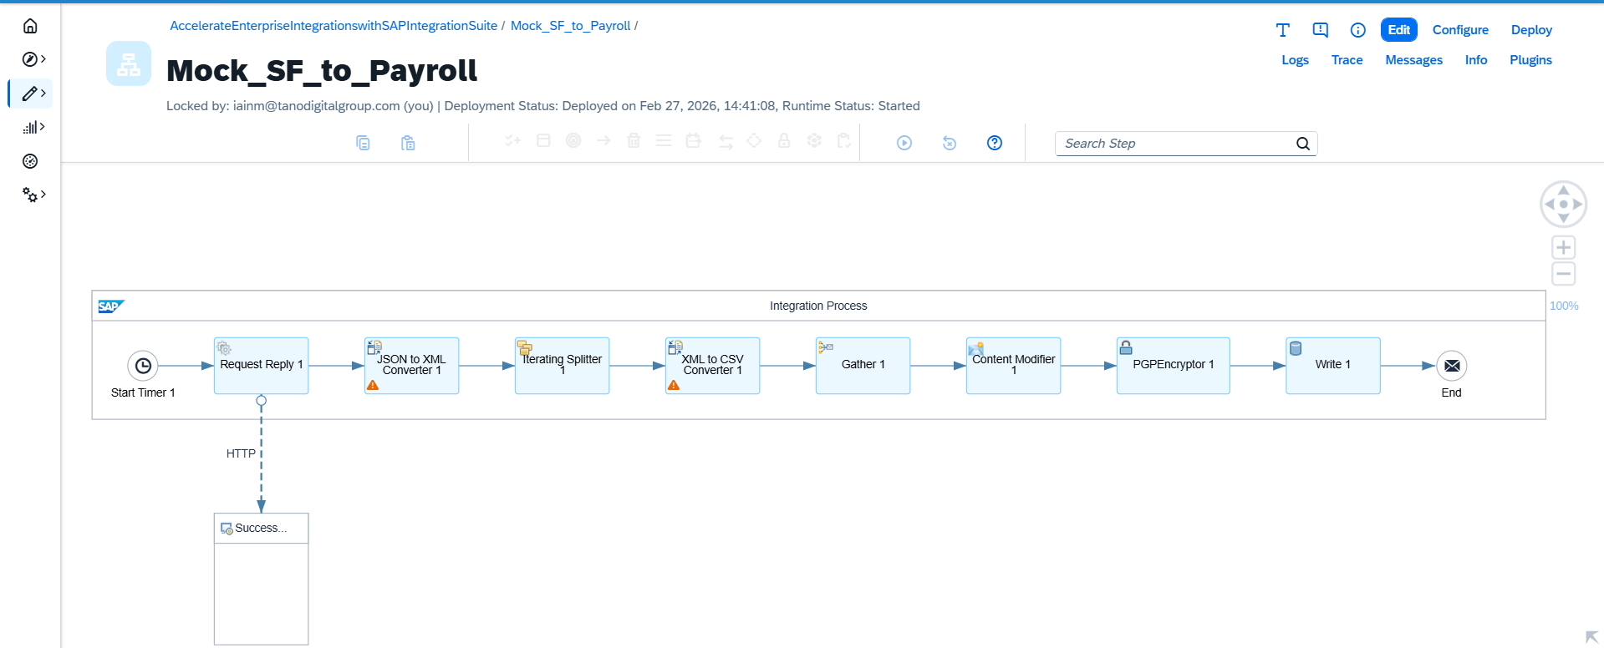
Step | Component | Configuration / Purpose
1 | Timer Start | Trigger: Scheduled. Controls when the batch job initiates.
2 | Request Reply (HTTP) | Action: Fetches the mock employee payload via a GET request to the webhook URL.
3 | JSON to XML Converter | Action: Converts the incoming REST/JSON response into XML.  Note: "Add XML Root Element" is disabled as the source data natively contains a <root> object.
4 | Iterating Splitter | Action: Prevents Out-Of-Memory (OOM) errors by chunking the payload.  XPath: /root/d/results  Grouping: 1 (Processes one employee node at a time).
5 | XML to CSV Converter | Action: Flattens the hierarchical XML into a legacy flat-file format.  Source Path: results  Headers: Disabled (to prevent header duplication in the loop).
6 | Gather | Action: Collects all individual CSV chunks and merges them into a single file.  Format: Plain Text  Algorithm: Concatenate
7 | Content Modifier | Action: Injects the required CSV column headers at the top of the concatenated file.  Body: userId,firstName,lastName,email,department,status,country followed by ${in.body}.
8 | PGP Encryptor | Action: Secures the file using the vendor's Public Key.  Key User ID: Belina_Mock (Substring match for Keystore Alias).  Format: Binary (Armored).
9 | Data Store Write | Action: Persists the final encrypted payload for extraction/delivery.  Data Store Name: Payroll_Export_Test  Entry ID: Encrypted_CSV  Note: "Overwrite Existing Message" is enabled for testing purposes.
10 | End Event | Terminates the successful transaction.
4. Error Handling & Limitations
- Data Overwrites: Currently, the Data Store step is configured to overwrite the Encrypted_CSV entry on every run. In a production environment, the Entry ID should be made dynamic using an expression like ${date:now:yyyyMMdd} to maintain historical logs.
- Key Management: The PGP Encryptor relies on a "Bring Your Own Key" (BYOK) model. If the vendor updates or rotates their keys, the new .asc public key must be uploaded to the SAP CPI Keystore and the mapping updated.

